1. Which are the top three variables in your model which contribute most towards the probability of a lead getting converted?

**Ans:** The top three variables in our model which contribute the most towards the lead getting converted are:

* Lead Origin
* Last Notable activity
* What is your current Occupation

The following table shows the importance of each variable wrt their coefficients:

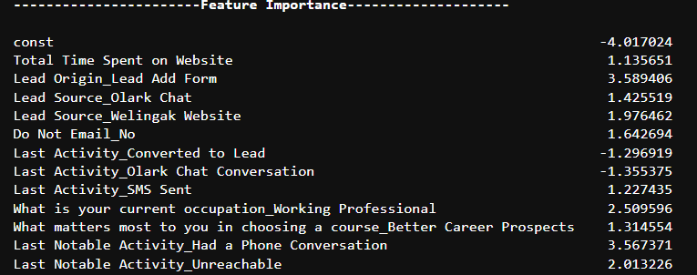

1. What are the top 3 categorical/dummy variables in the model which should be focused the most on in order to increase the probability of lead conversion?

**Ans:** Upon reviewing the final model and which is evident from the EDA the top 3 categorical/dummy variables in which the company should focus to increase the lead conversion are:

* Lead Origin – Lead Add Form
* Last Notable Activity – Had a phone conversation
* What is your current occupation – Working Professional.

**Lead Origin**

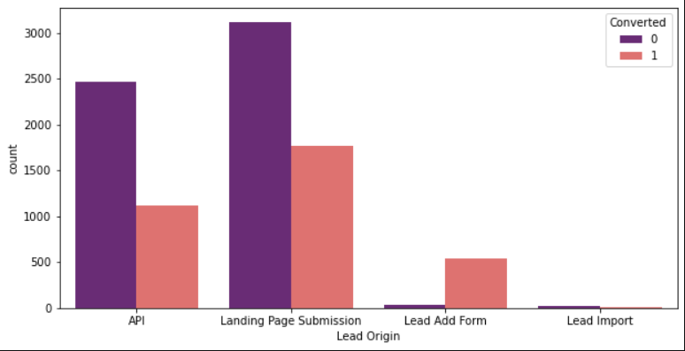

**What is your current Occupation**

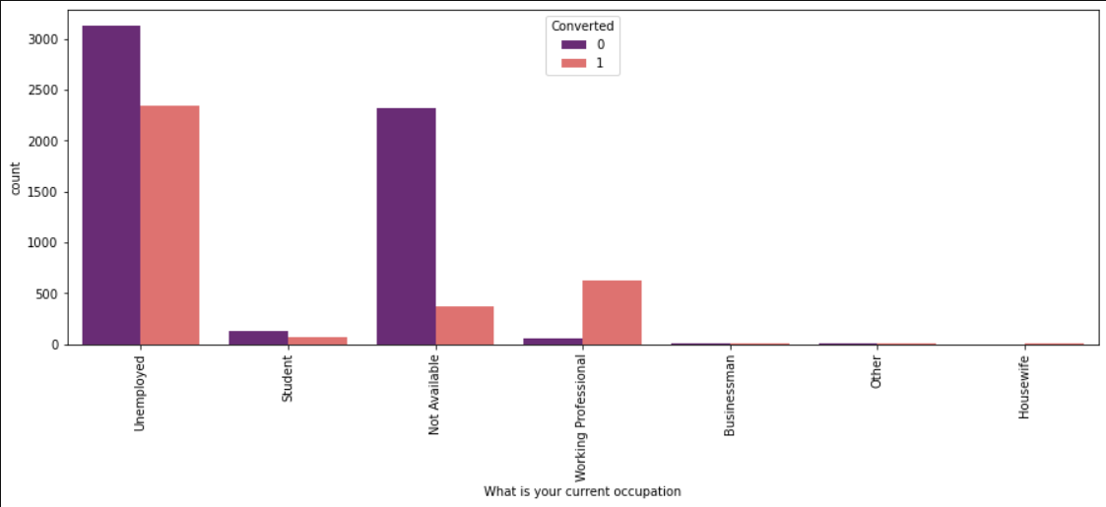

1. X Education has a period of 2 months every year during which they hire some interns. The sales team, in particular, has around 10 interns allotted to them. So, during this phase, they wish to make the lead conversion more aggressive. So, they want almost all of the potential leads (i.e. the customers who have been predicted as 1 by the model) to be converted and hence, want to make phone calls to as much of such people as possible. Suggest a good strategy they should employ at this stage.

**Ans:** They can make calls to as much of such people as possible by considering the below factors if:

* People spend a lot of time on their website and this can be achieved by making the website more interesting which indulges the lead to spend more time.
* The leads are working professionals or Unemployed.
* Their lead source is from OLARK Chat.
* The leads wanted to have a better career prospect by choosing the course.

1. Similarly, at times, the company reaches its target for a quarter before the deadline. During this time, the company wants the sales team to focus on some new work as well. So during this time, the company’s aim is to not make phone calls unless it’s extremely necessary, i.e. they want to minimize the rate of useless phone calls. Suggest a strategy they should employ at this stage.

**Ans:** In this situation they need to focus more on their other methods like:

* Focusing on activities such as personalized emails or SMS
* Call only when it is an emergency for customers having very high chance of buying the course.
* Focus on building relationships with potential customers through other communication channels like social media or chat bots.